Iter1.4 Prototype
G3T3
Inspirations
1. Inspiration 1: Life360
2. Inspiration 2: Strava
3. Inspiration 3: Noonlight
Navigation Diagram
Prototype
1. Login Page
2. Create Account Page
3. Select Role: User/Watcher Page
4. User mode: Enter Next of Kin Details for User
5. Session Setup
6. Select Night Buddies from Contacts
7. Main Navigation Bar
8. Crew Tab
9. View Group Statuses: Safe vs Missing
10. Drinks Tab
11. Drinks Tracker & Pacing: Low/Med/High
12. Log Drink Type: Beer/Wine/Cocktail
13. Profile Tab
14. Manual Check-in & Status Tags
15. Set Check-In Intervals
16. SOS Emergency Trigger
17. Map Tab Active
18. Map Tab Inactive: View Own Location & Battery Pin
19. View Member Location and Battery Pins
20. Automated Well-Being Check-in
21. User Responds ‘OK’, proceed back to Map Tab
22. User unresponsive: Trigger Missing Alert & Notification appears on Watcher Dashboard
23. Track Active Session & Map
24. Press ‘End Session’ Button
25. Book a ‘SafeSip’ Driver
26. Select Role: Watcher
27. Enter Watcher/Child details
28. Watcher sees the well-being notification on Watcher Dashboard
29. Track Active Session & Map

Inspirations

Inspiration 1: Life360
SafeSip’s location sharing system is inspired by Life360’s circle-based location sharing model. The members within the same circle can see one another’s real-time location on a shared map. This adaptation is specifically for nightlife safety, so parents and friends can keep track of someone during the specific window of a night out.
Features Adopted:
- Live Map View - shows exact location of the person on a shared map
- Circles/Groups - separates different groups of people e.g., family group, friend group
- Location History - past locations within the night
- Alerts - notifications when someone arrives or leaves location e.g., house/ restaurants/ bars
How SafeSip Differs:
- Automated Well-Being Check - At regular intervals when the user is not within close proximity of Night Buddies, a well-being check-in is triggered. If someone misses their well-being check-in, their circle members and next-of-kin will be alerted automatically to check in on them
- Shared Sober Tracking & Pace Dashboard - A real-time drink logger where users track their consumption and pace. This data remains visible to their designated circle during an active session to maintain peer accountability
- Session-Based Location Sharing - To preserve user autonomy and avoid constant surveillance, live location sharing is limited to active "Night Out Sessions". This gives parents peace of mind without compromising the student's privacy.
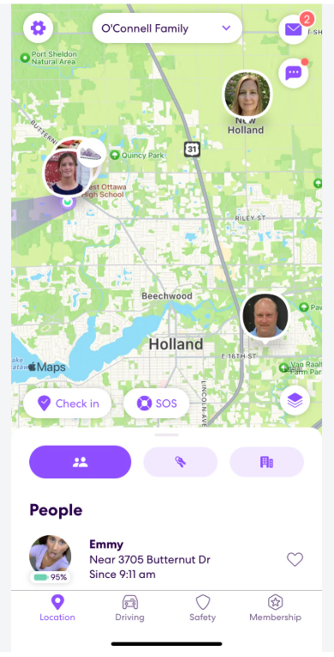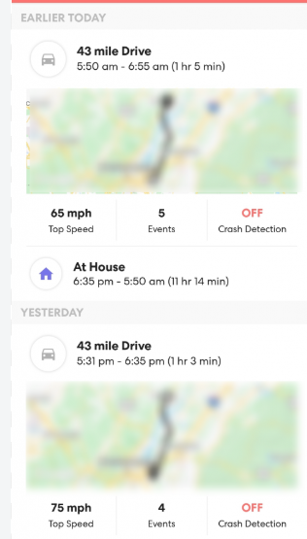

Inspiration 2: Strava
SafeSip leverages Strava’s live telemetry and movement-tracking model to analyze continuous real-time movement, speed shifts, and pace during a night out.
Features Adopted:
- Speed & Pace Analytics: Differentiates between walking, running, stationary periods, or riding in a vehicle.
- Night Route Timeline: Displays the exact visual path taken on a map throughout the night out.
- Unplanned Stop Alerts: Flags prolonged, unexpected stops outside designated safe venues (e.g., stopping suddenly mid-street).
- Heart Rate Monitoring: Use smart devices (e.g., Apple Watch) to monitor heart rate and blood pressure throughout the night.
How SafeSip Differs:
- Nighttime Anomaly Detection: Unlike Strava’s fitness focus, SafeSip uses speed spikes for safety. If a user suddenly transitions from walking to vehicle speeds without initiating a "Ride Mode," or begins running unexpectedly late at night, the app triggers an immediate Wellbeing Check-in.
- Temporary Privacy Windows: Routes are not public feeds; trajectory data is strictly visible to the trusted circle only within the active night-out time window.
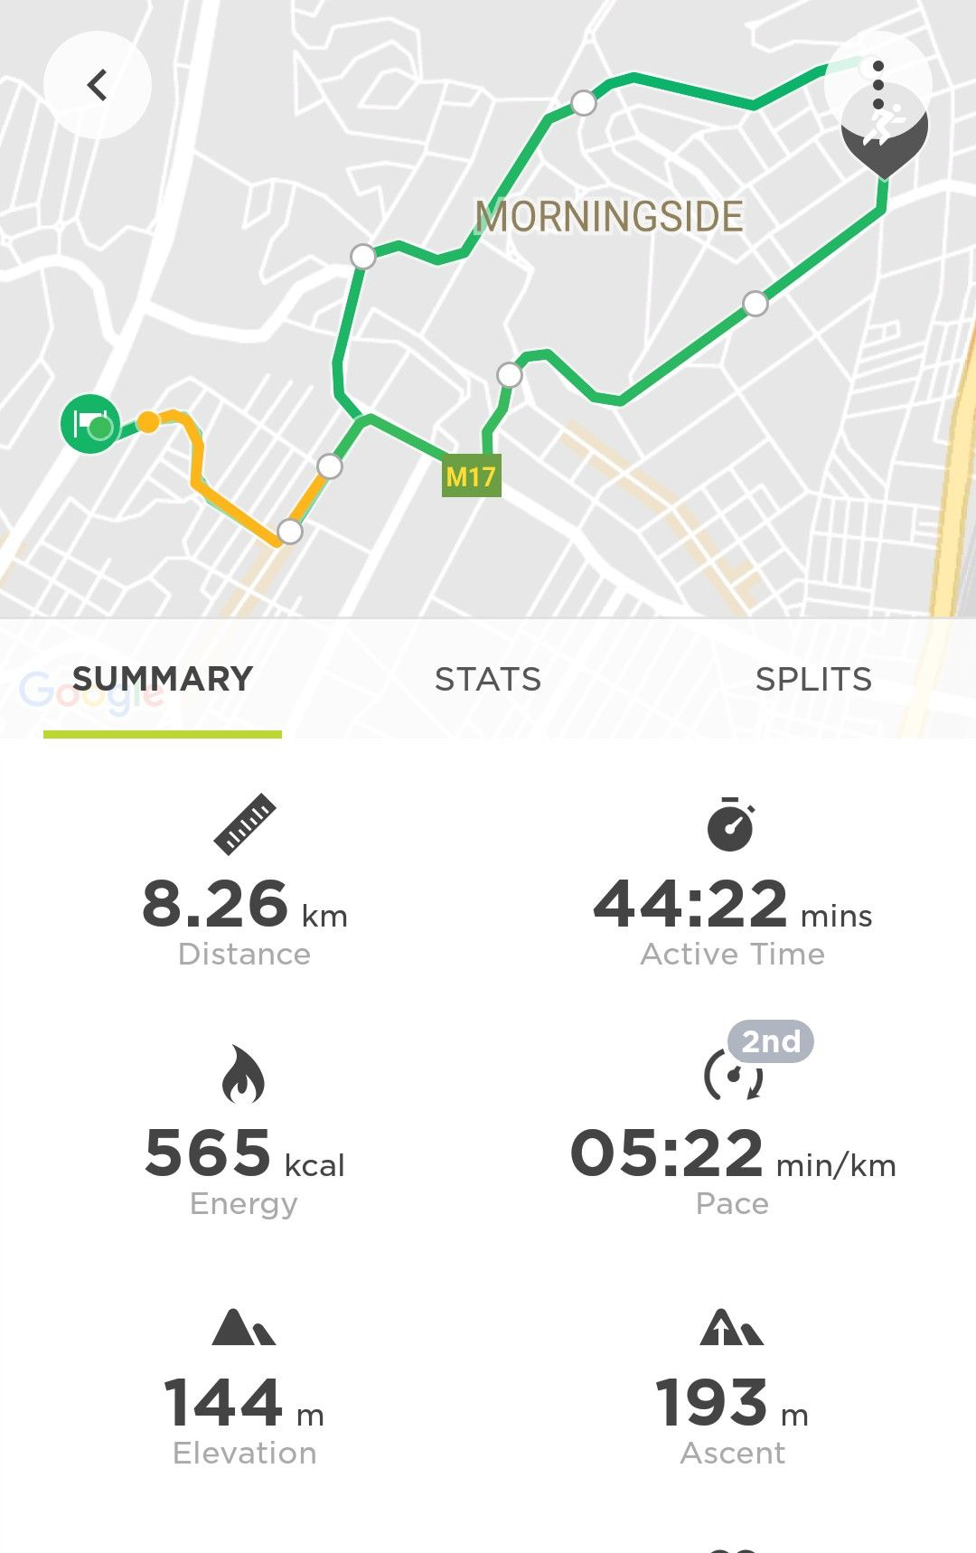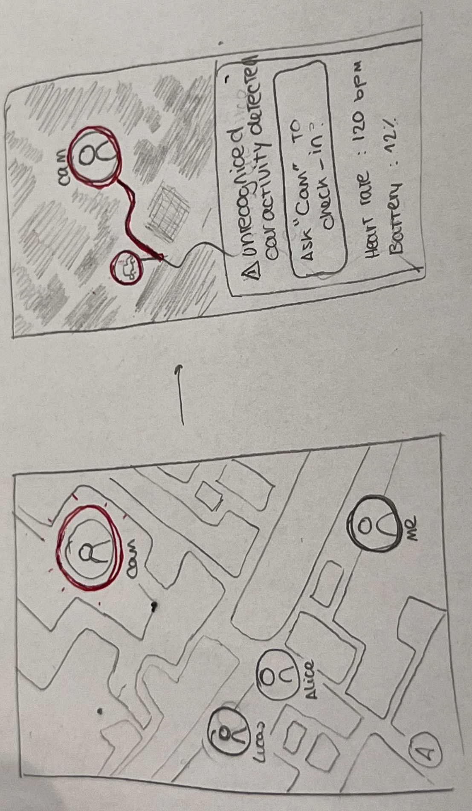

Inspiration 3: Noonlight
SafeSip’s active emergency response and automated alerts are inspired by Noonlight, a personal safety app built around active hold-and-release safety buttons and silent emergency triggering during unsafe situations.
Features Adopted:
- Silent Emergency Trigger: A quick, low-friction gesture to send immediate distress signals without attracting attention.
- Contextual Data Sharing: Automatically sending relevant details (last known location, active route, circle contacts) to chosen emergency contacts when an alert is triggered.
- Automated Escalation: System prompts that automatically escalate to alerts if the user fails to enter a pin code within a set time frame.
How SafeSip Differs:
- Nightlife-Specific Automation: Noonlight requires manual activation in scary situations. SafeSip uses passive safety timers tied to night outs (e.g., "Estimate time home: 20 mins"). If the user doesn't confirm arrival home, the alert triggers automatically. This is ideal for situations where a student may have overconsumed or lost track of time.
- Peer-First Network: Instead of routing straight to third-party call centers or police, SafeSip alerts the user's trusted circle first (friends on the night out), keeping the response immediate, peer-driven, and supportive.
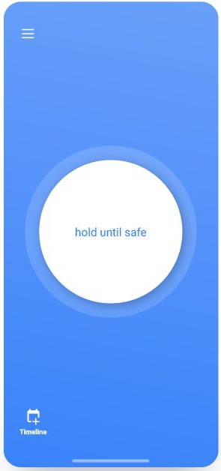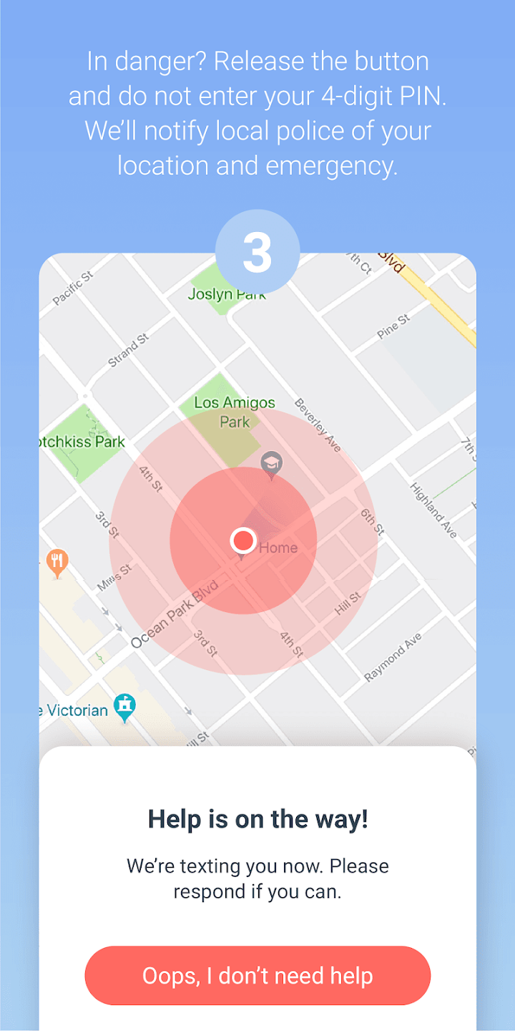

Navigation Diagram
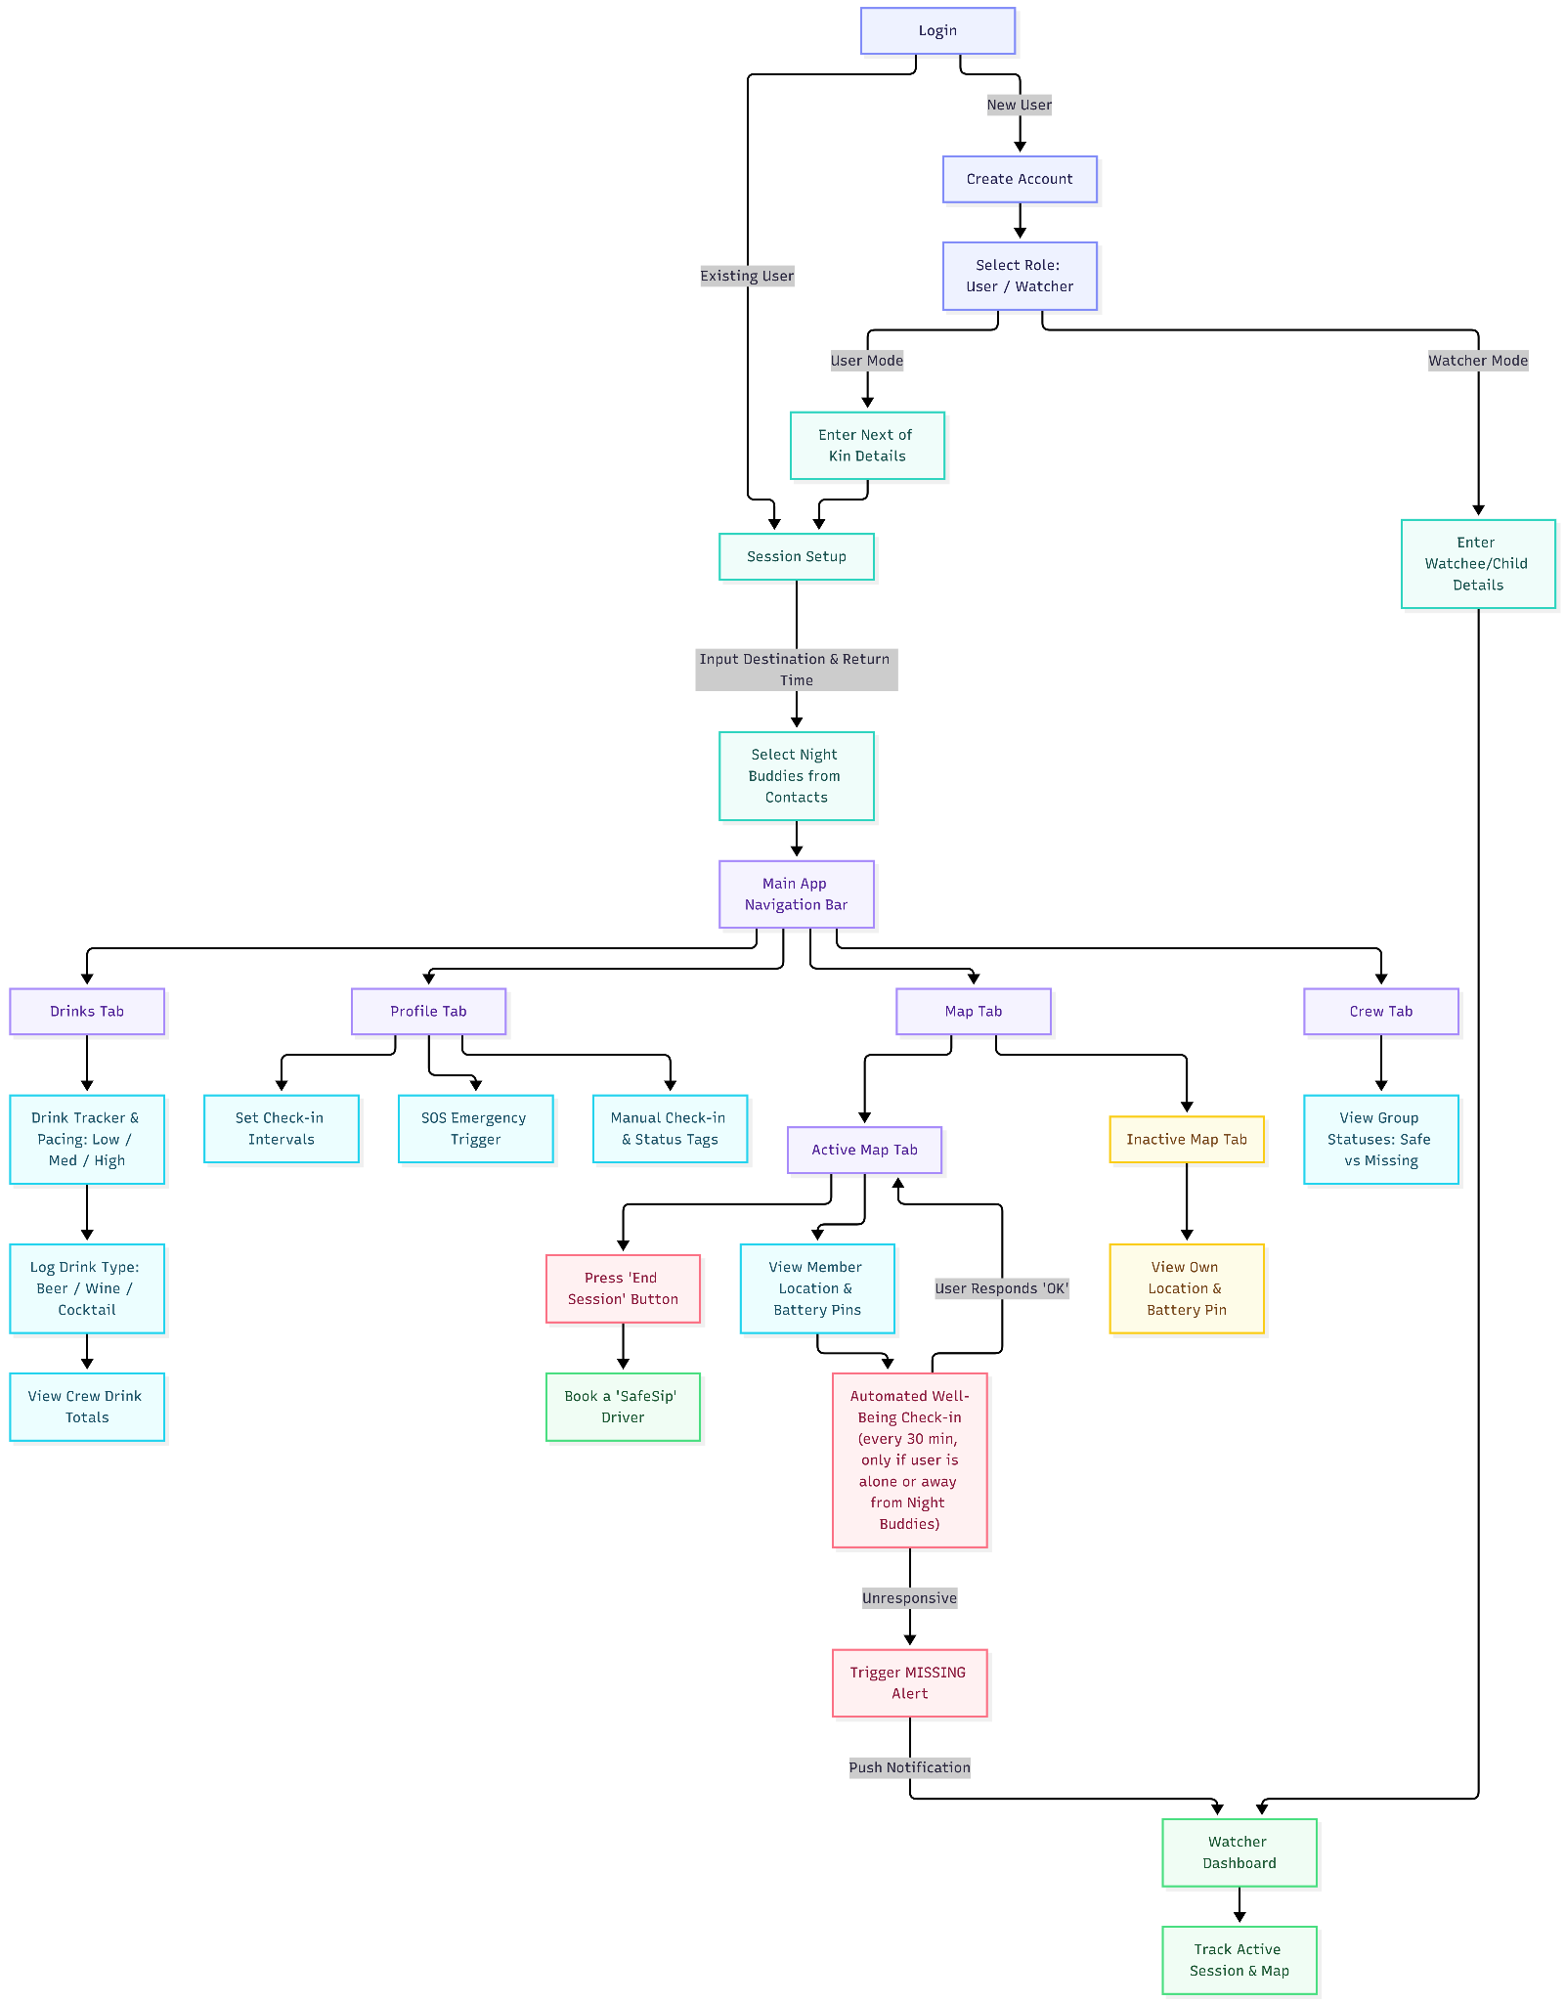

Prototype
We conducted parallel prototyping using AI (Figma Make & Google Stitch), creating 3 prototypes, which can be accessed below. After which, we met up and decided on the best features and styles from all 3 prototypes to combine into our final paper prototype.
- https://www.figma.com/make/T1LNv59Zw6lwV45S4kE0Qx/Peer-Support-Network?t=00RTRoaCSozbhS6O-1 [Created using Figma by Ameeka]
- https://www.figma.com/make/FJDN8jSYdbZfEJ9tj5F5QY/Low-Fidelity-SafeSip-Prototype?p=f&t=bZDAuapVjY5O7g1S-0 [Created using Figma Make by Jeffers]
- https://stitch.withgoogle.com/projects/14723083957594923496 [Created using Google Stitch by Sean]
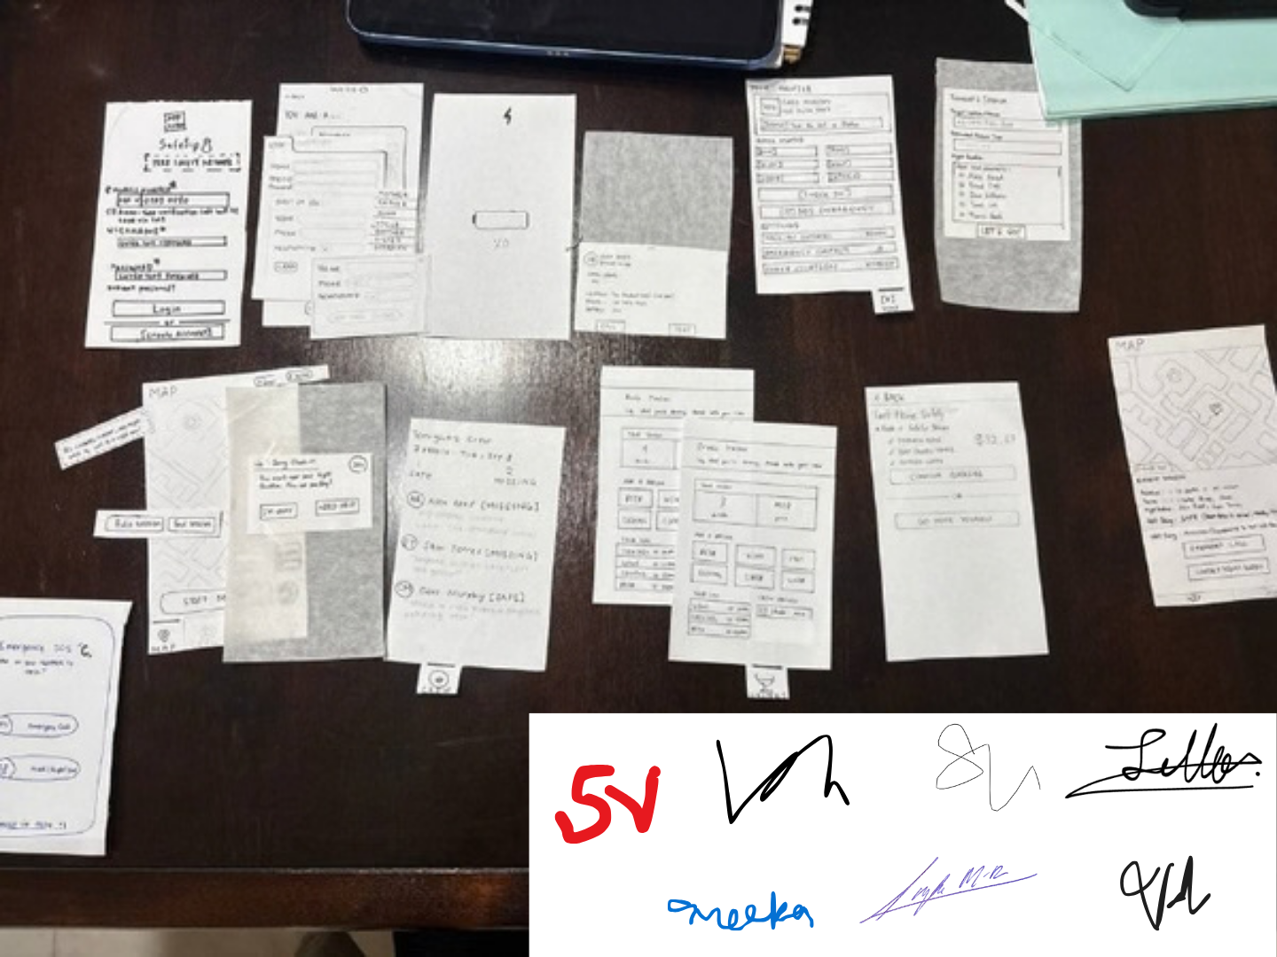

Paper Prototype

Login Page
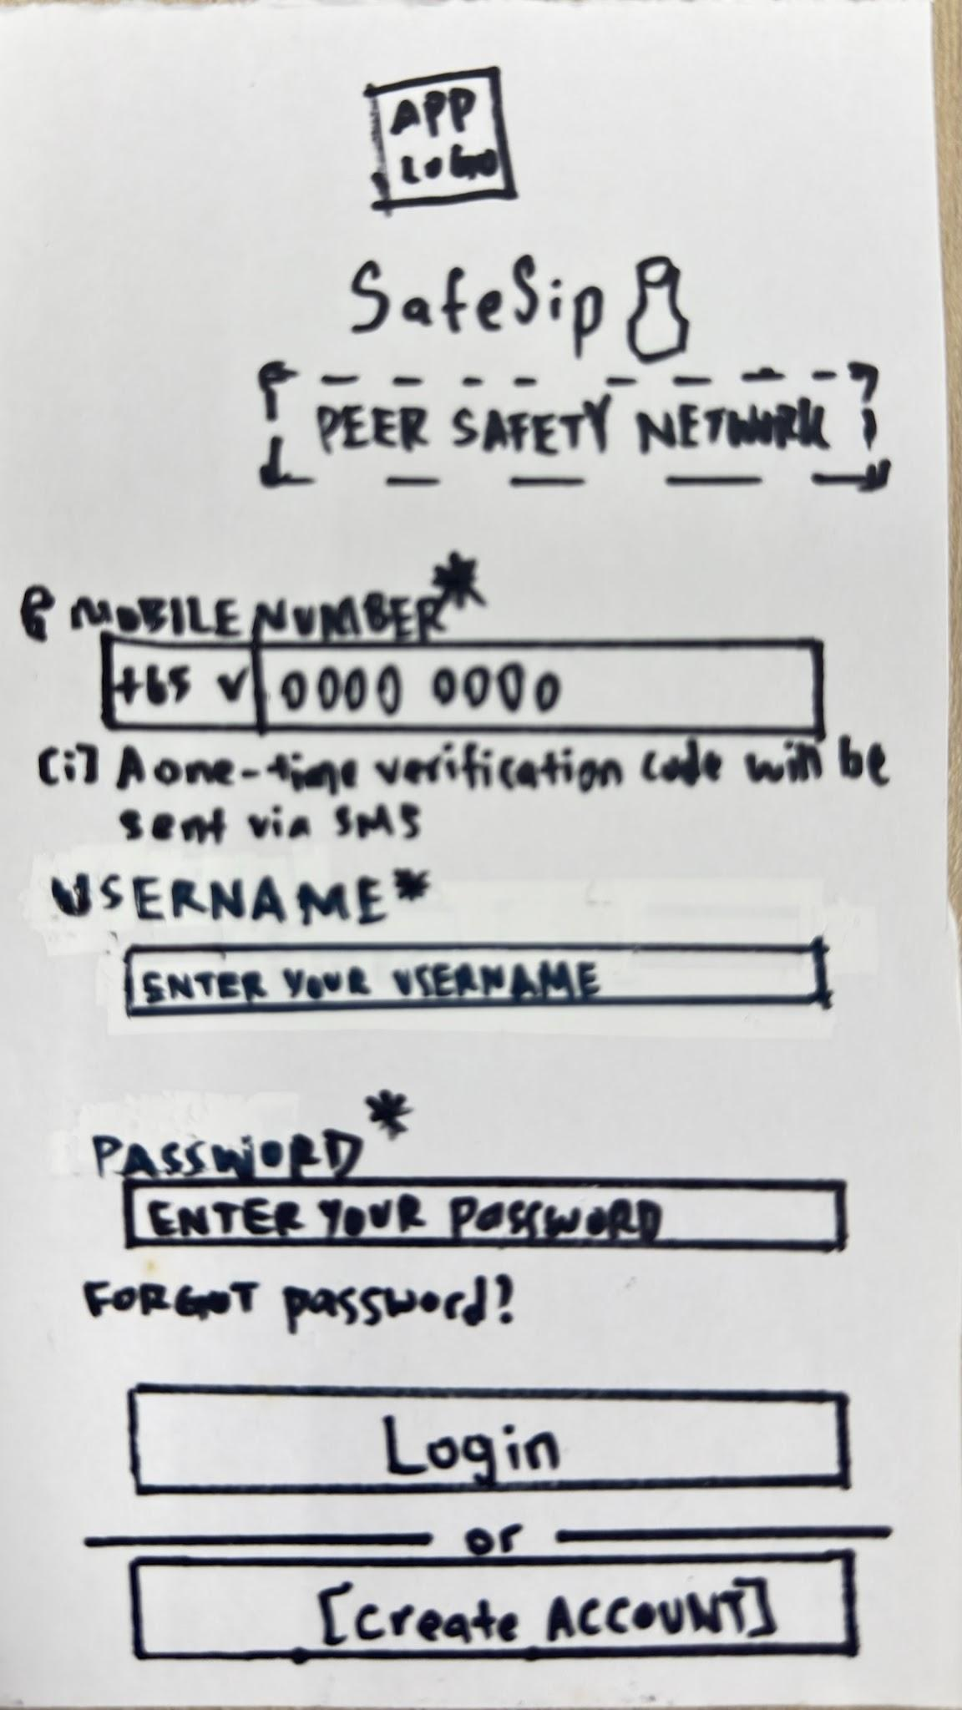

Create Account Page
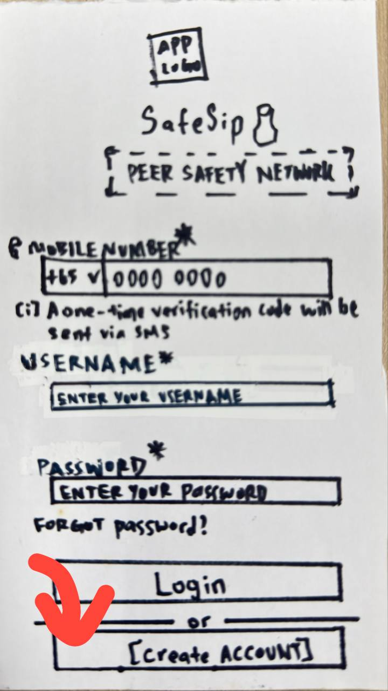

Select Role: User/Watcher Page
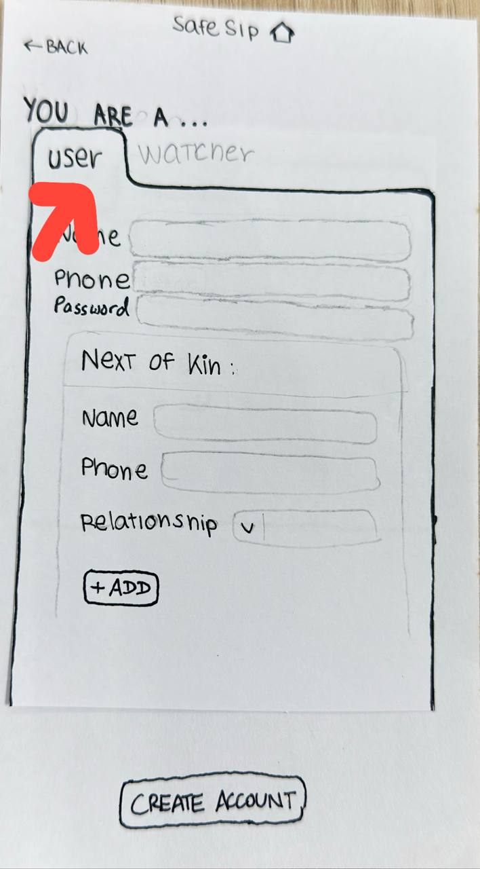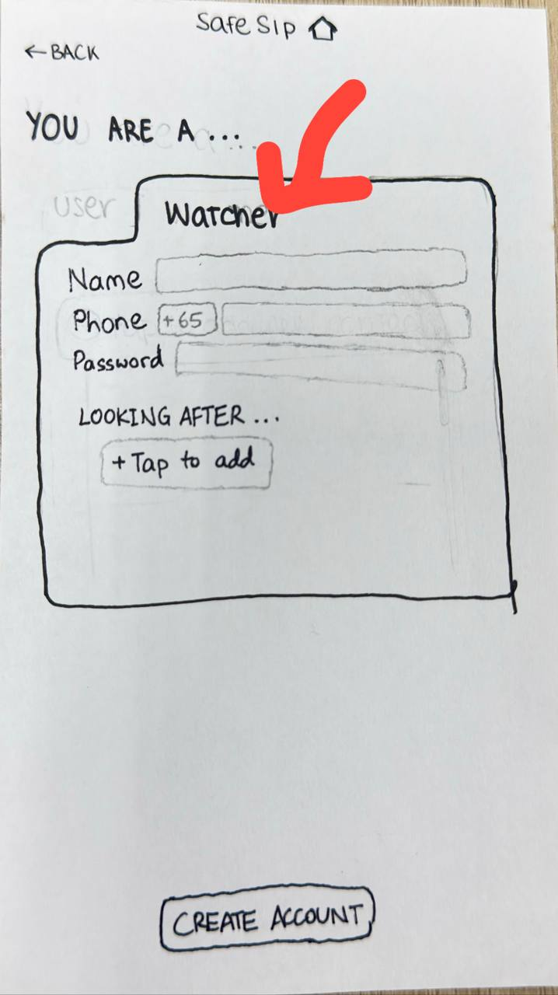

User mode: Enter Next of Kin Details for User
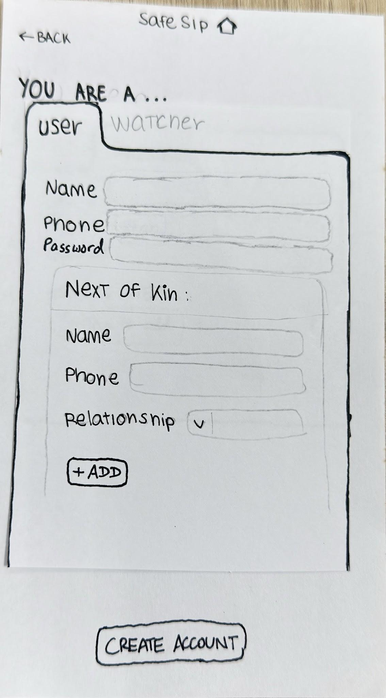

Session Setup
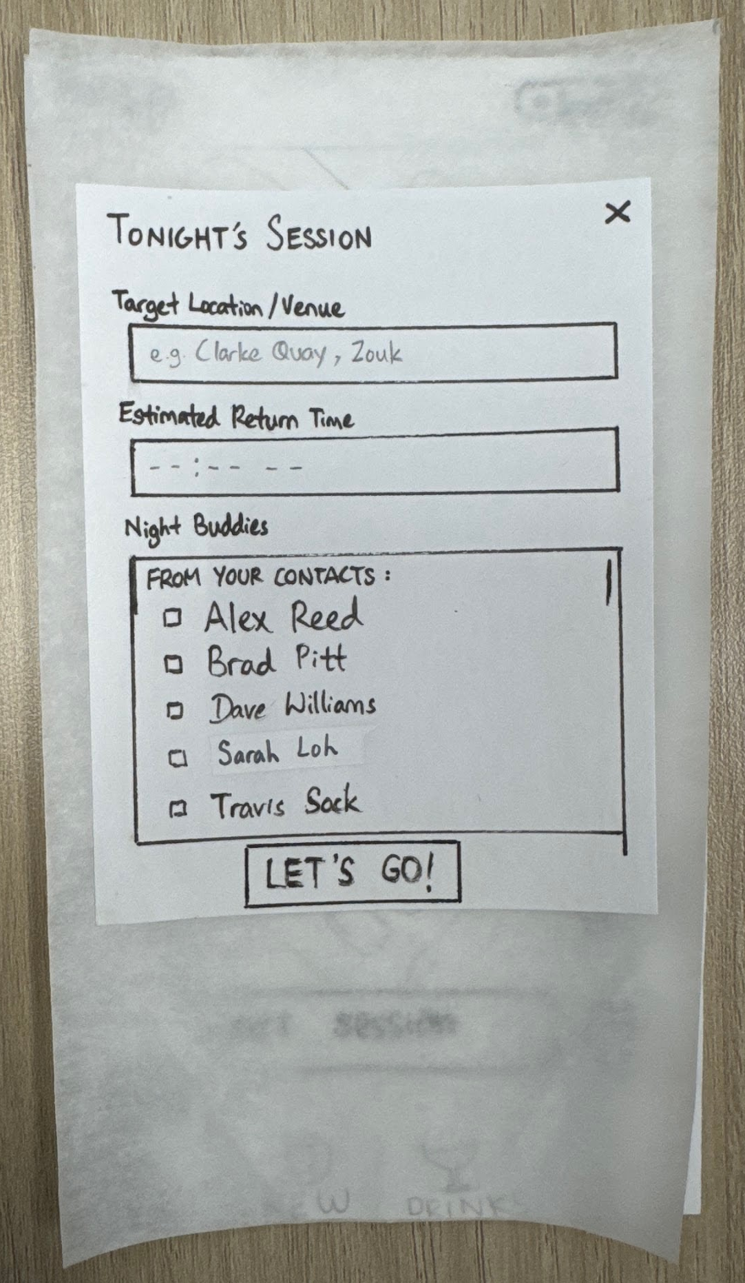

Select Night Buddies from Contacts
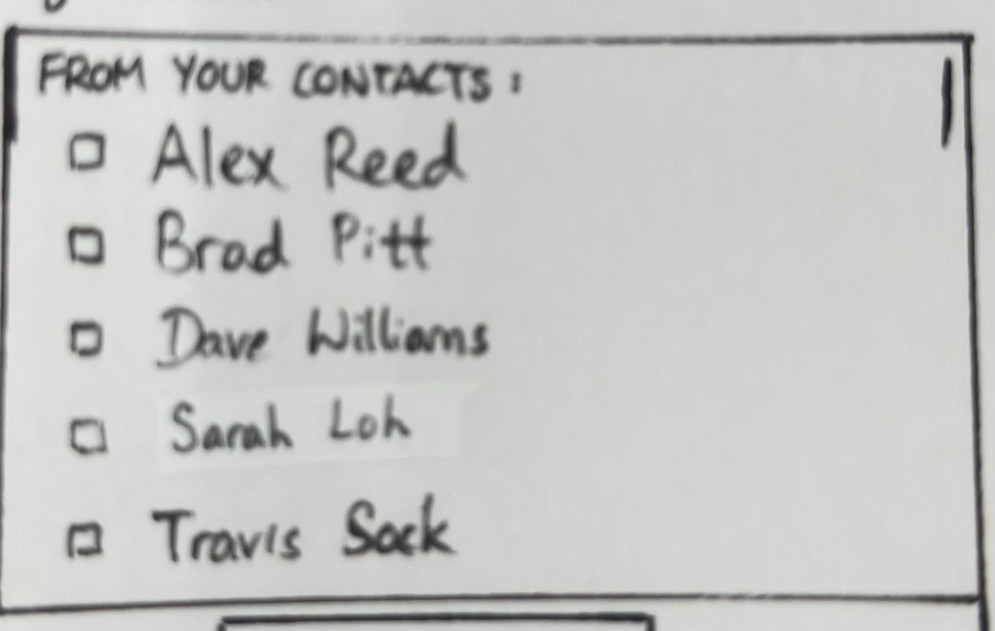

Main Navigation Bar
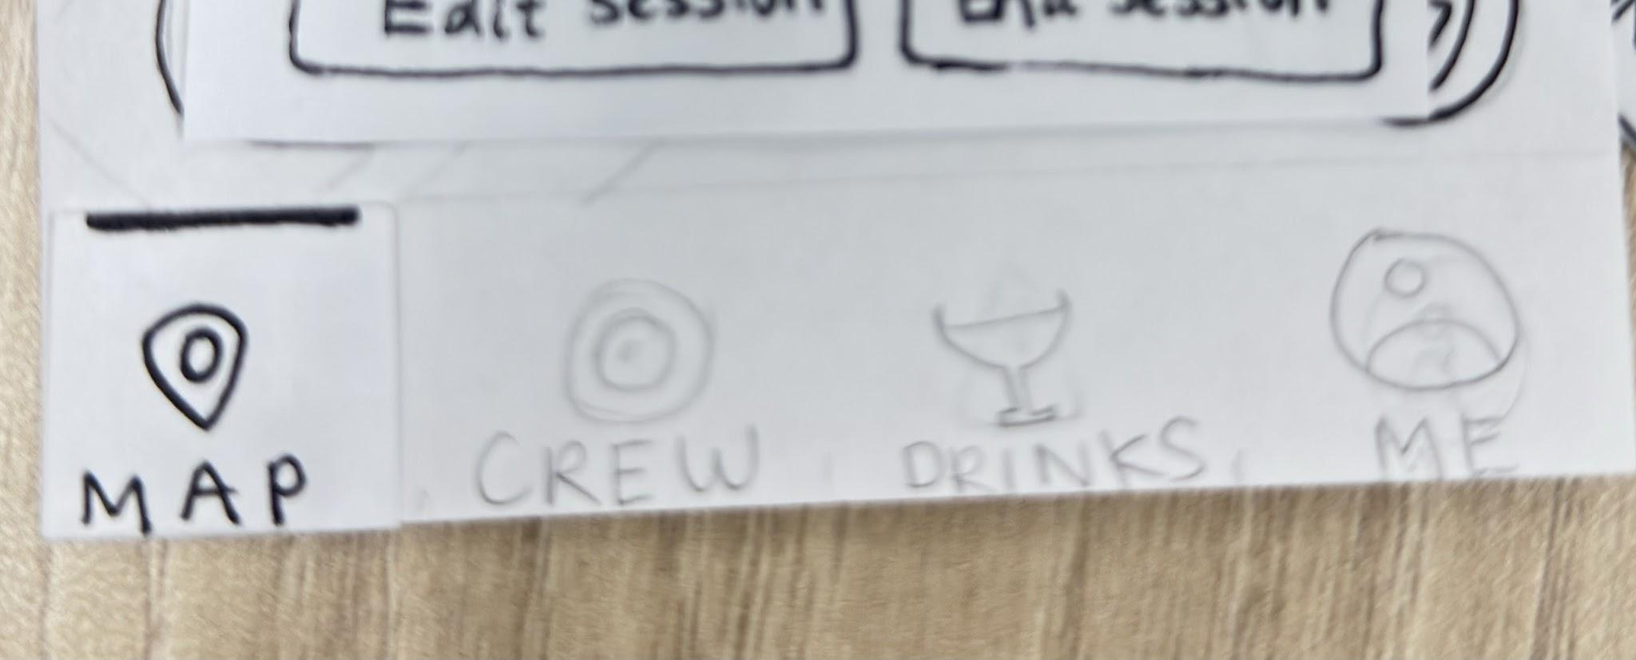

Crew Tab

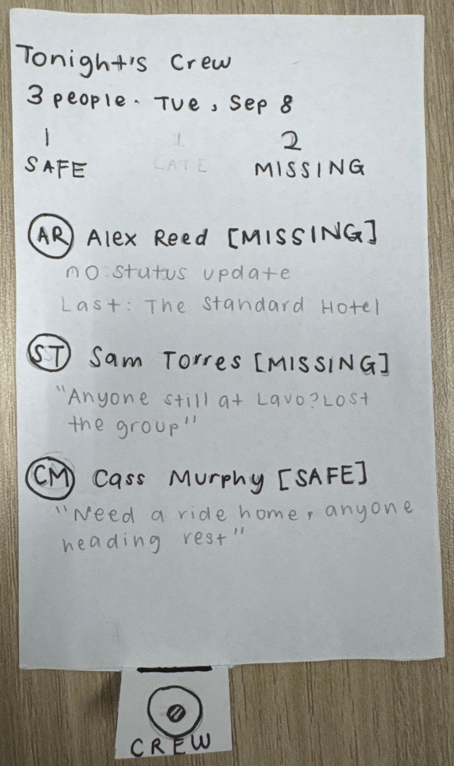

View Group Statuses: Safe vs Missing
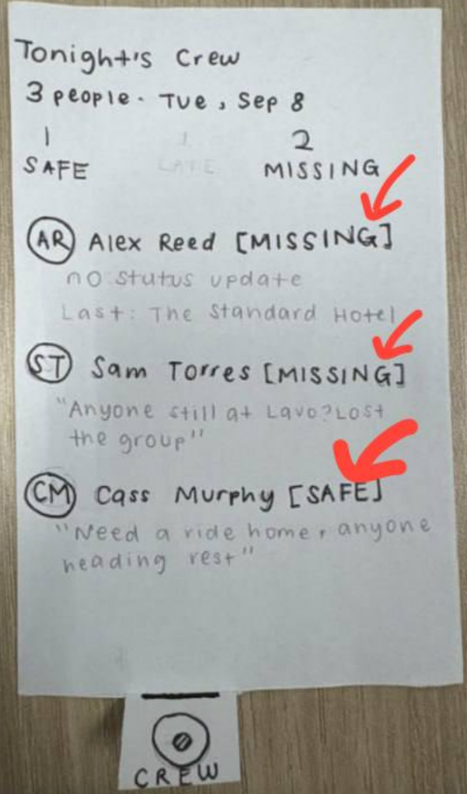

Drinks Tab
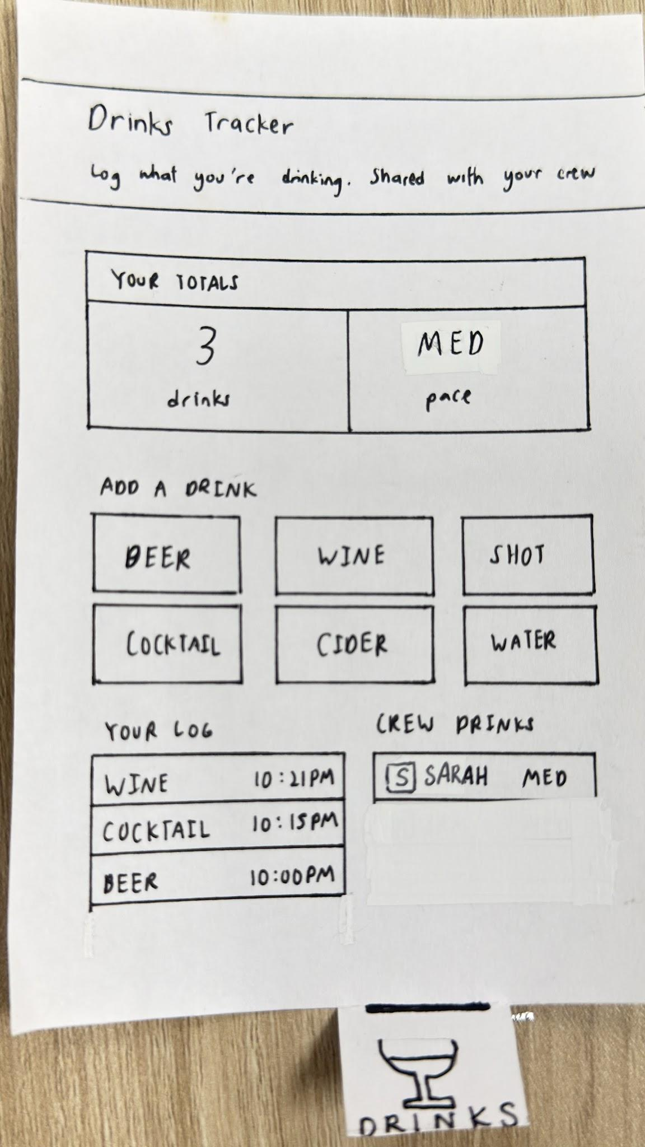

Drinks Tracker & Pacing: Low/Med/High
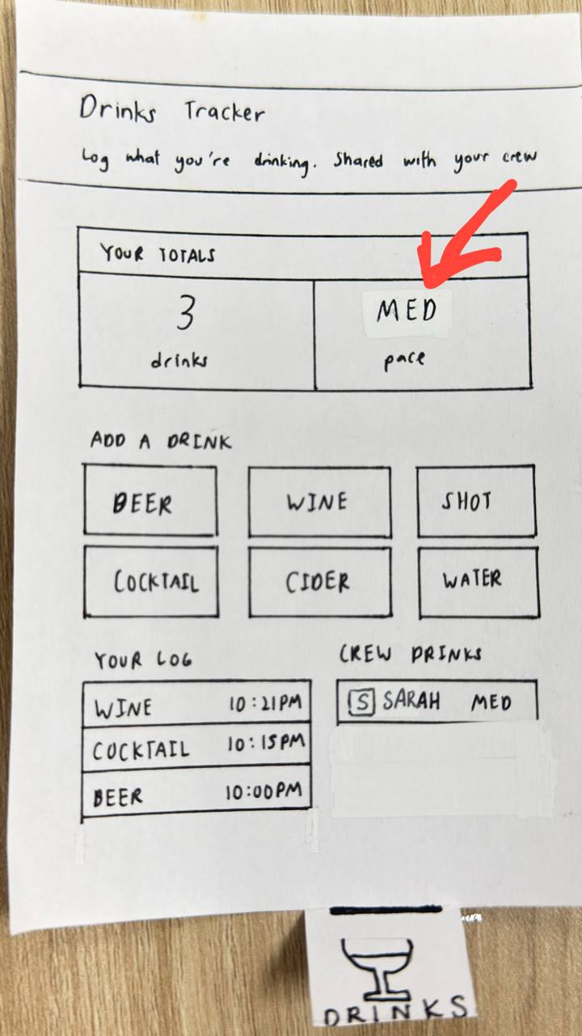

Log Drink Type: Beer/Wine/Cocktail
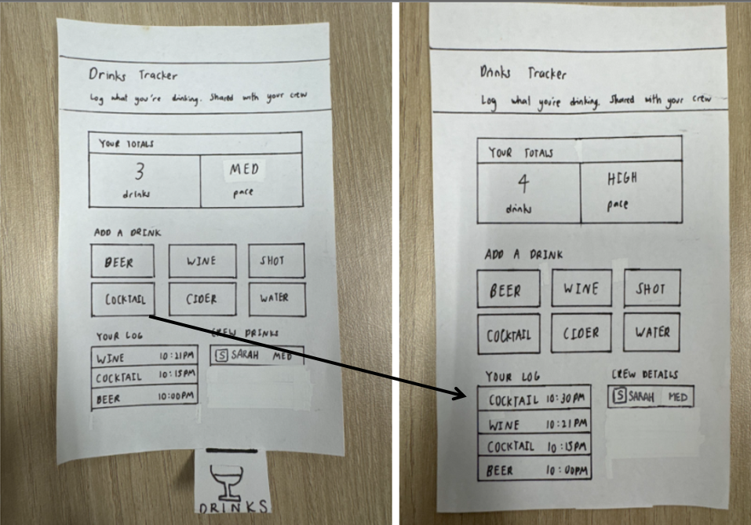

Profile Tab
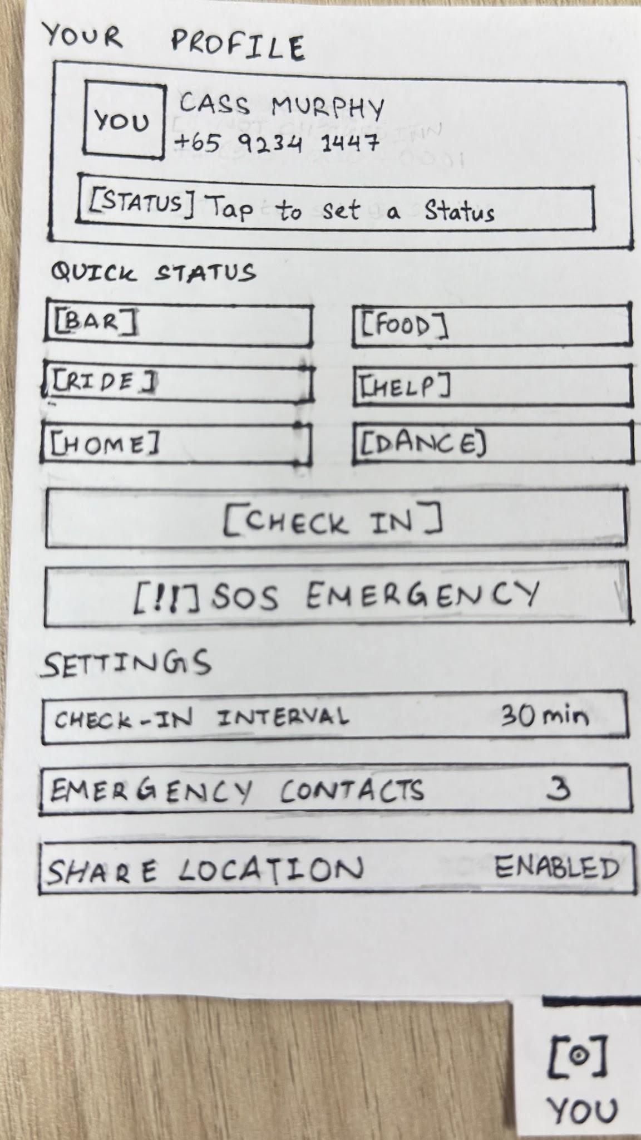

Manual Check-in & Status Tags
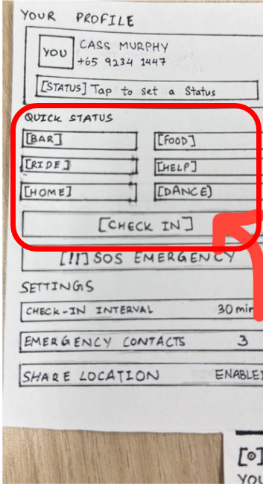

Set Check-In Intervals
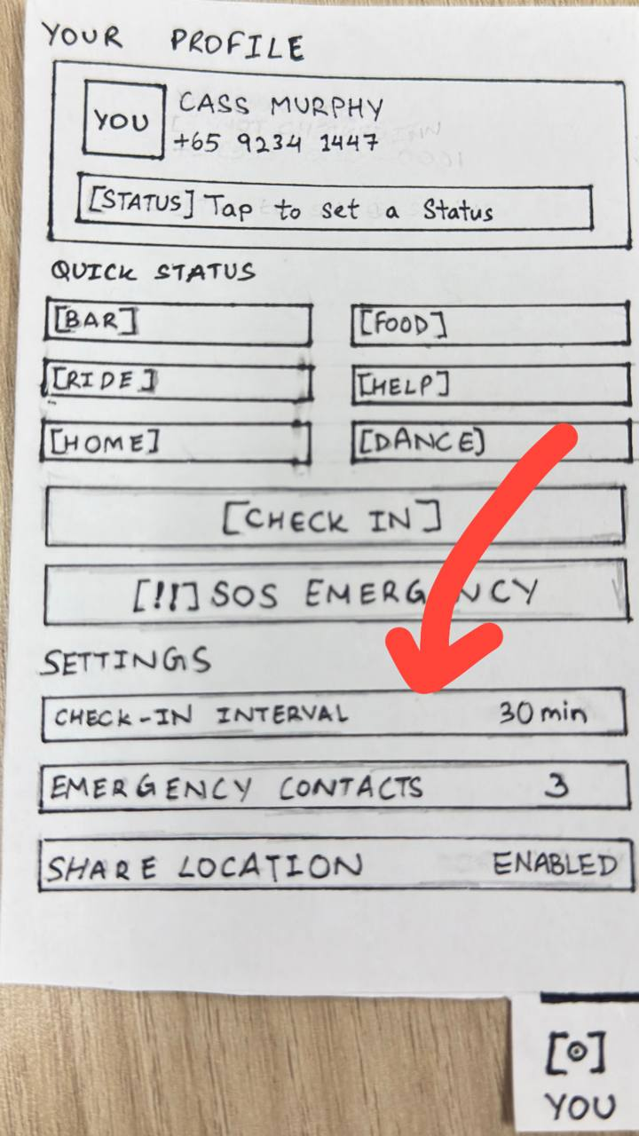

SOS Emergency Trigger
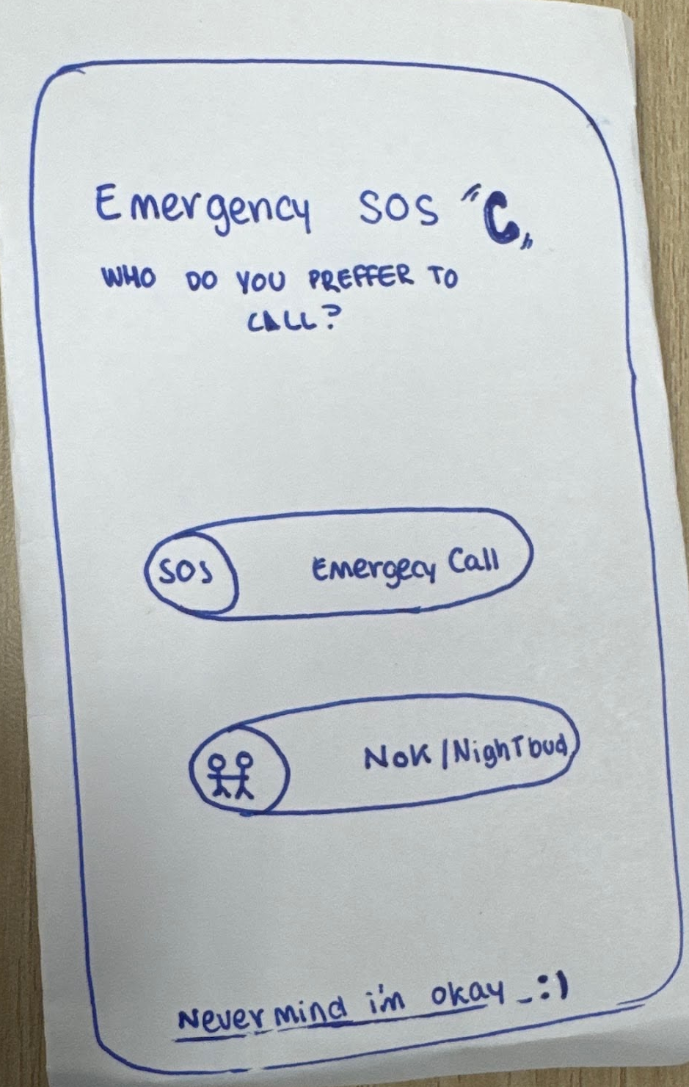

Map Tab Active
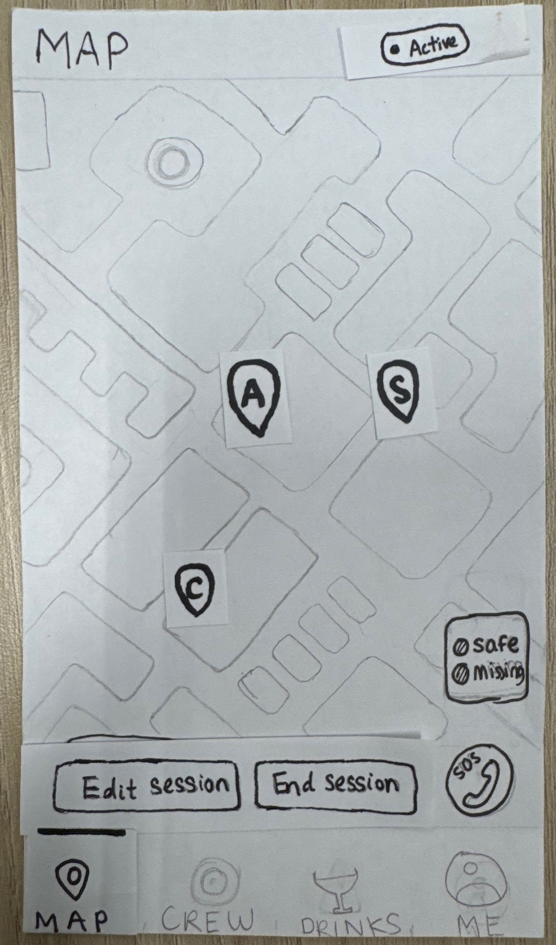

Map Tab Inactive: View Own Location & Battery Pin
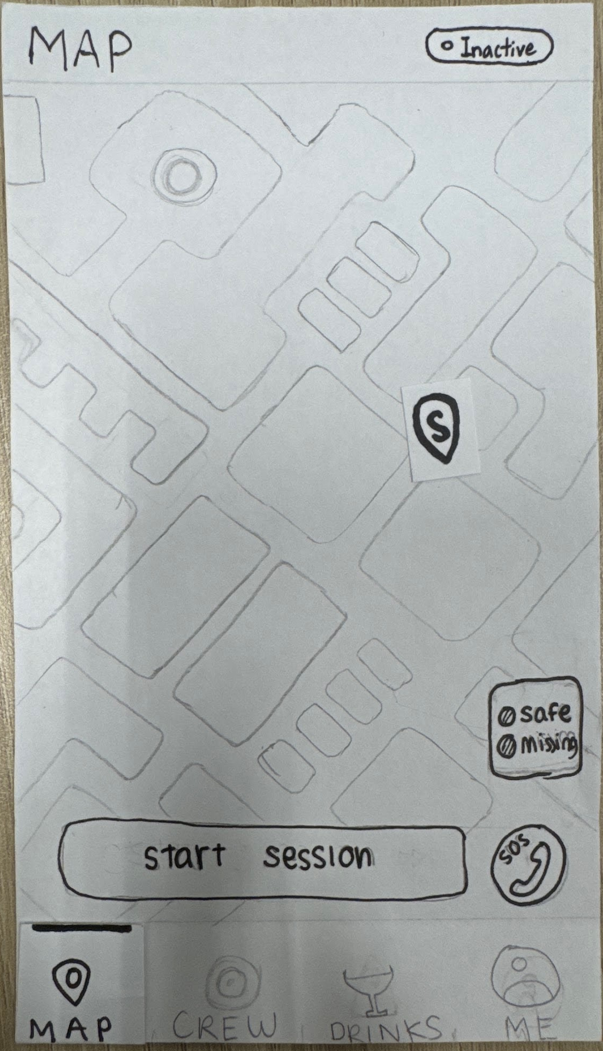

View Member Location and Battery Pins
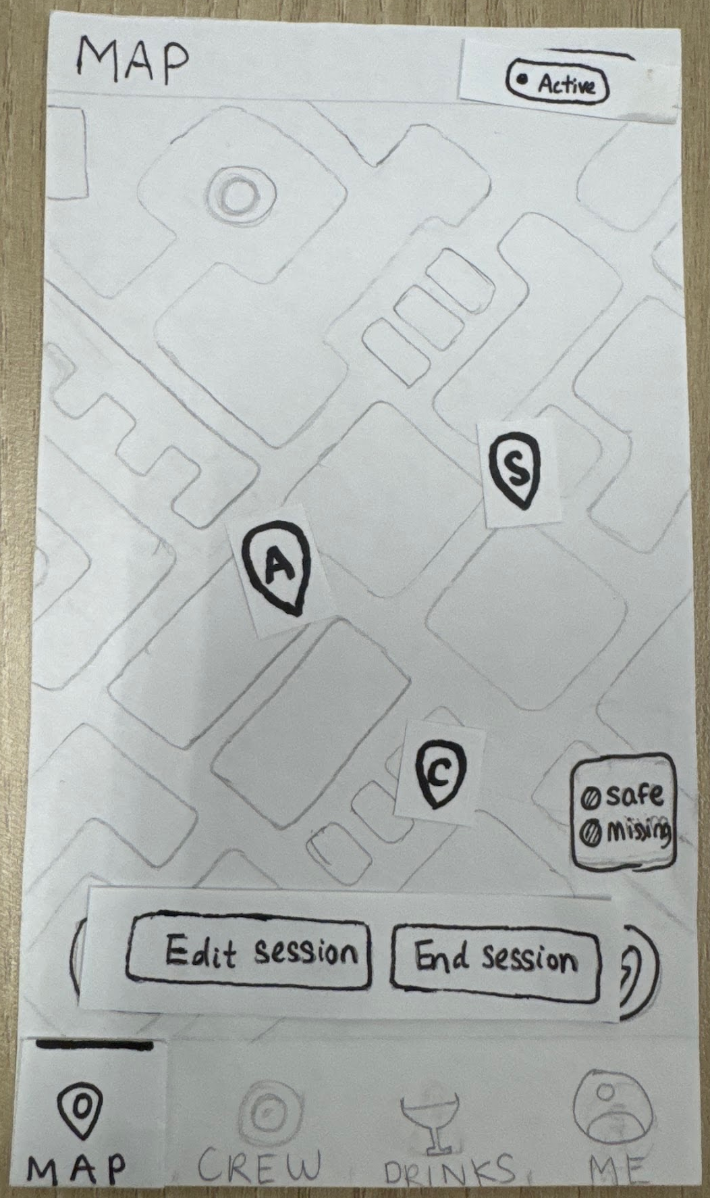

Automated Well-Being Check-in
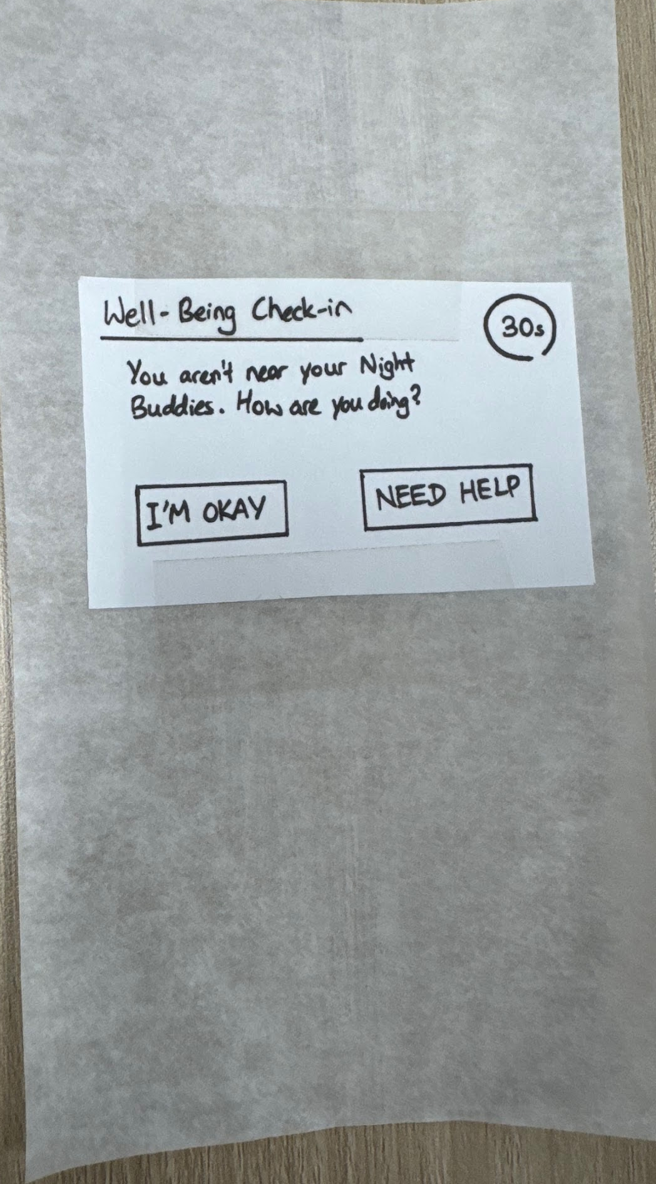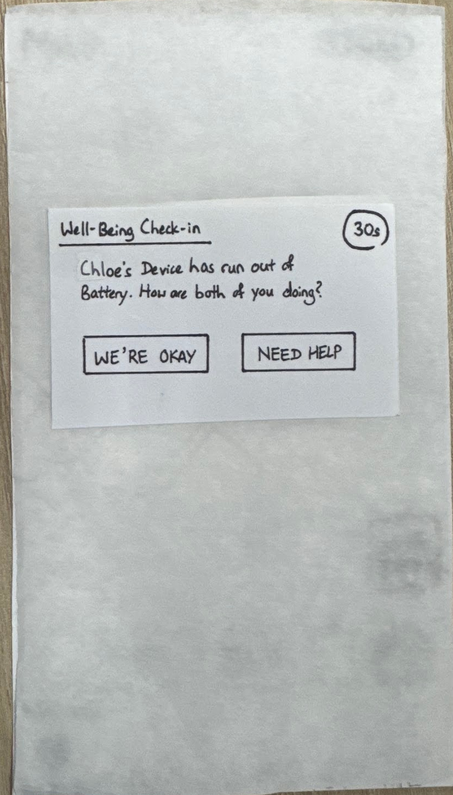

User Responds ‘OK’, proceed back to Map Tab
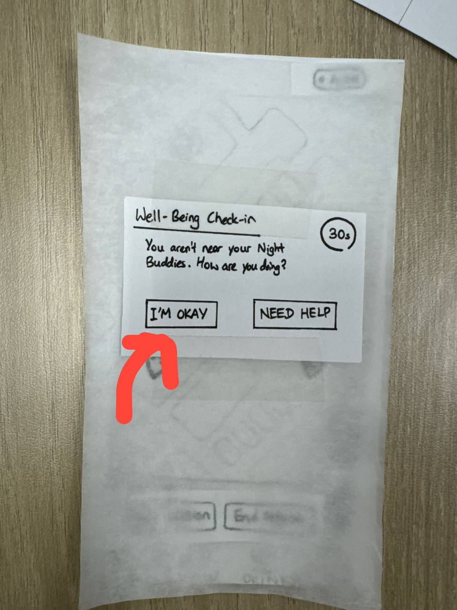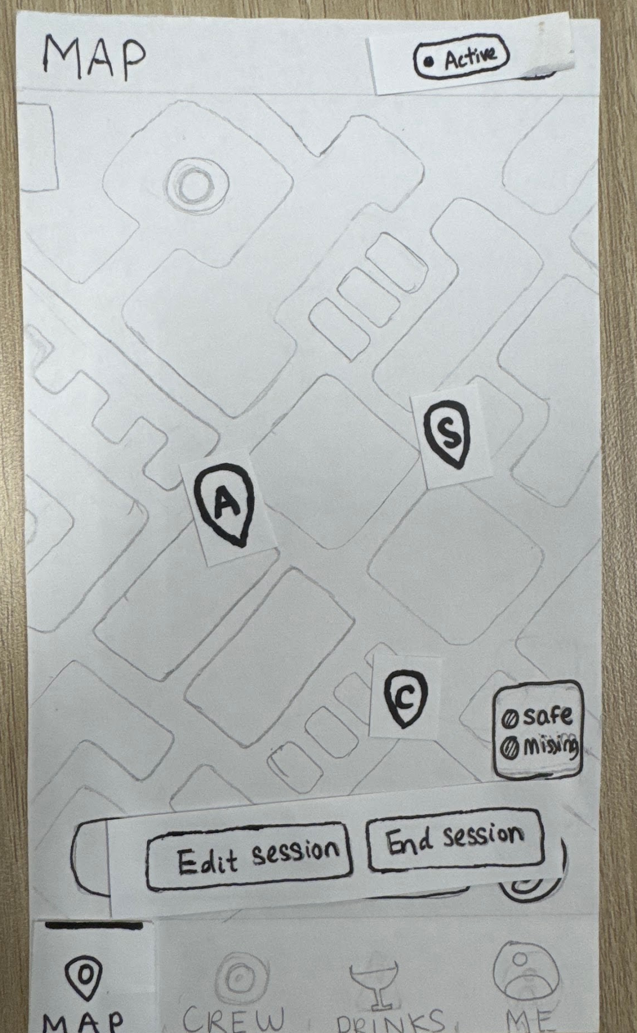

User unresponsive: Trigger Missing Alert & Notification appears on Watcher Dashboard
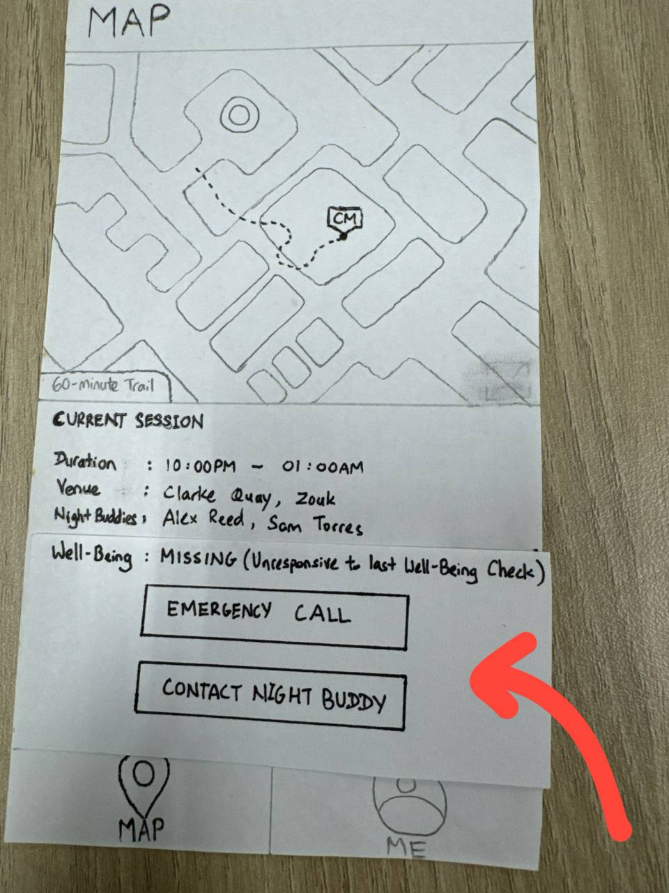

Track Active Session & Map
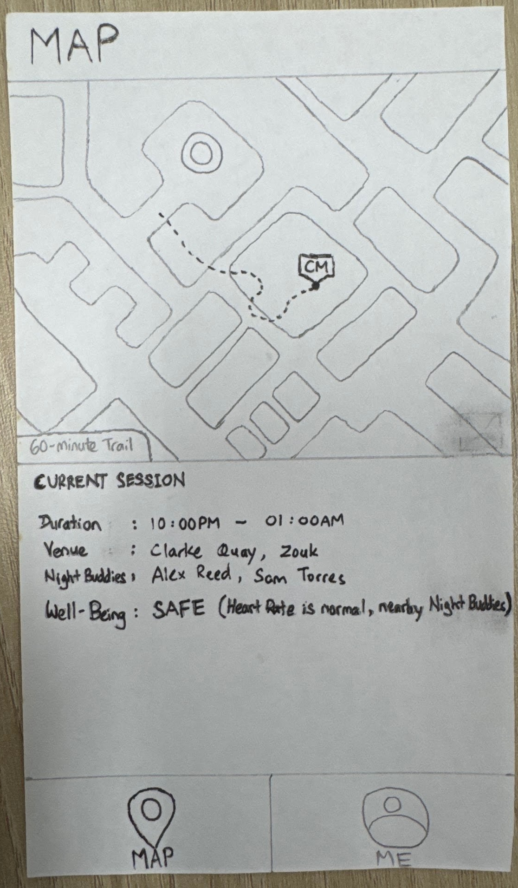

Press ‘End Session’ Button
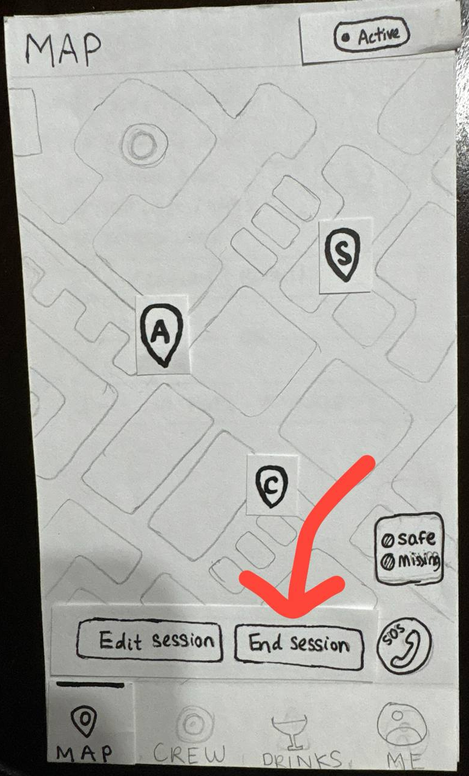

Book a ‘SafeSip’ Driver
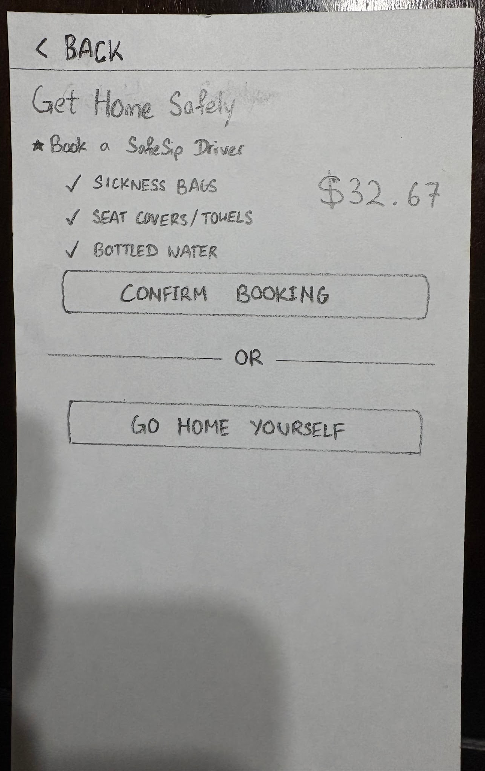

Select Role: Watcher
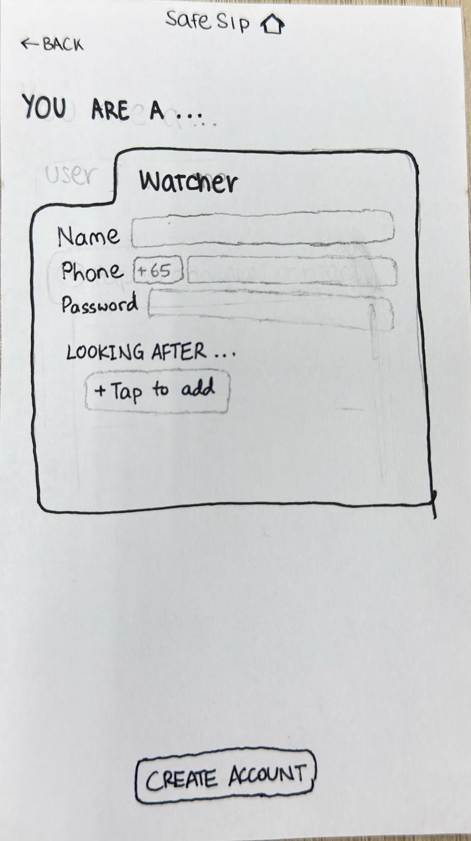

Enter Watcher/Child details
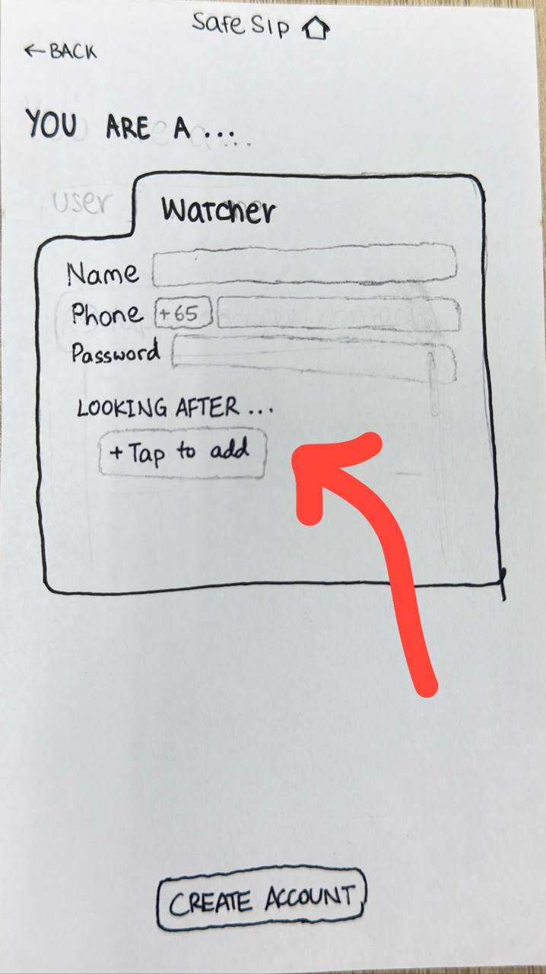

Watcher sees the well-being notification on Watcher Dashboard

Track Active Session & Map

